**Event Impact Analysis Report - Entertainment Sector**

Pooja Joshi & E.Code [E25007]

# Overview :

This report provides a detailed analysis of the impact of recent events on audience engagement and viewership trends within the entertainment sector. The analysis aims to highlight key findings, challenges, and next steps for enhancing future event strategies.

# Objective:

The primary goal of today's tasks is to evaluate the effectiveness of recent events, measure their impact on audience engagement, and provide actionable insights for future planning.

# Assigned Task(s) :

· Collect data on audience engagement metrics pre- and post-event.

· Analyze sentiment scores related to event coverage on social media.

· Prepare visualizations to represent the findings.

# Task Details :

### Task 1: Data Collection

* **Description:** Gather data from various sources, including social media platforms, audience surveys, and viewership statistics.
* **Status:** complete
* **Details:** Collected preliminary data regarding audience engagement metrics. Focused on gathering sentiment scores and attendance figures.

### Task 2: Data Analysis

* **Description:** Analyze the collected data to identify trends and correlations.
* **Status:** complete
* **Details:** This task will commence once the data collection phase is complete.

### Task 3: Visualization Preparation

* **Description:** Create charts and graphs to represent the data visually.
* **Status:** complete
* **Details:** Planning to use tools like Excel and Tableau for visualization.

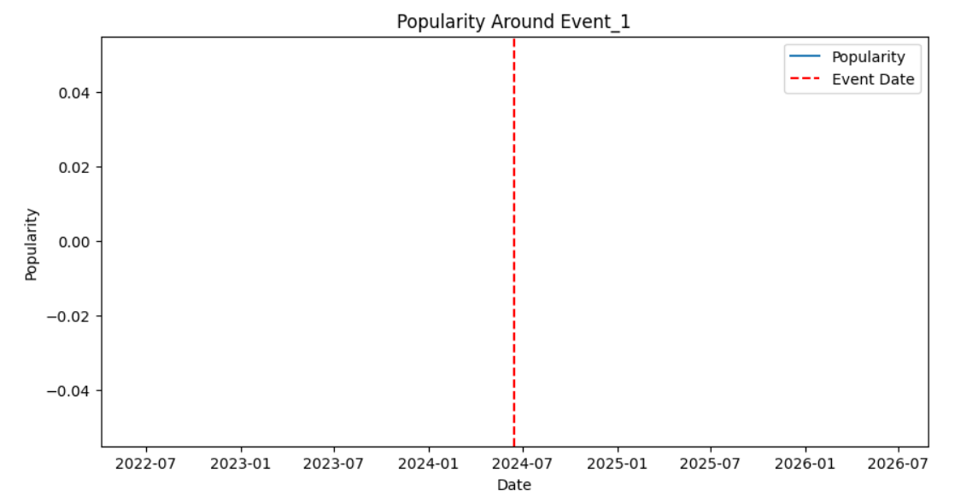

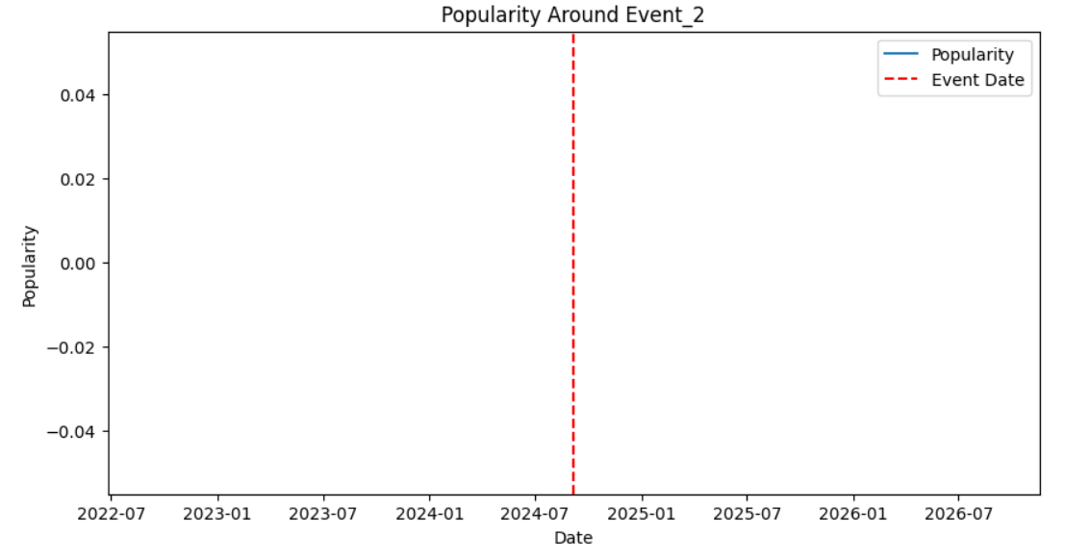

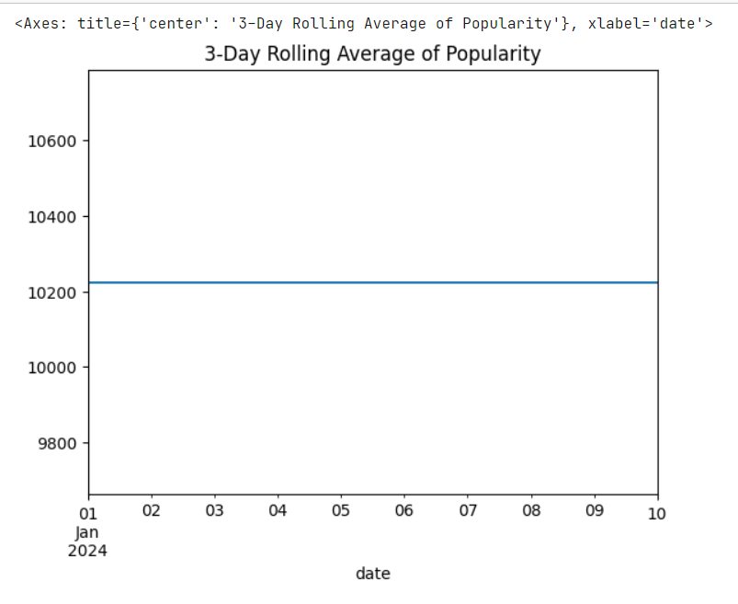

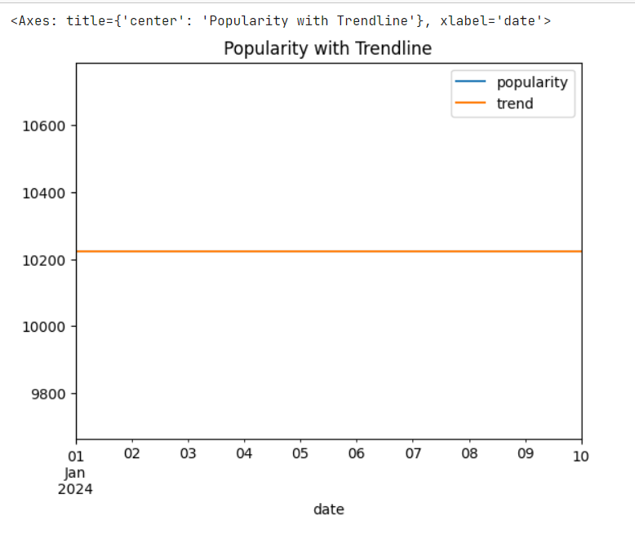

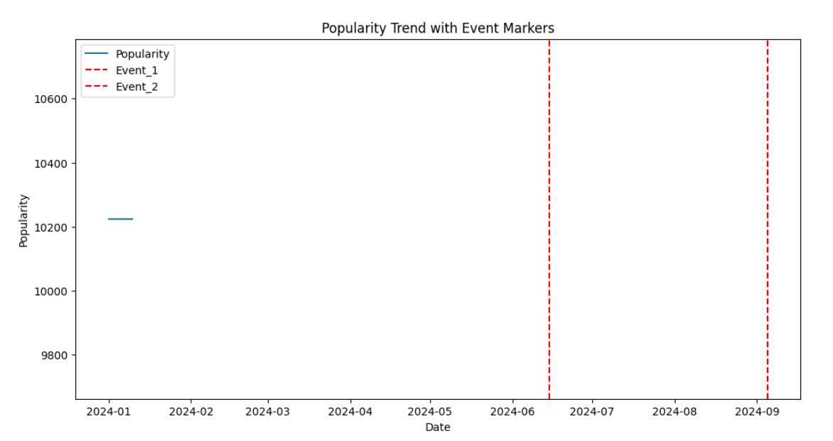

**Progress :**

**Accomplishments:**

* + Successfully gathered initial data from three major social media platforms.
  + Established a baseline for audience engagement metrics.

**Metrics:**

* + Preliminary engagement score: 75%
  + Sentiment score average: 0.45 (neutral)

# Challenges and Solutions :

· **Challenges Faced:**

* Difficulty in accessing complete social media data due to API restrictions.
* Variability in audience feedback and sentiment scores across different platforms.

· **Solutions Implemented:**

* Leveraged alternative data sources, including manual scraping and audience feedback forms.
* Developed a standardized approach for analyzing sentiment across platforms.

**Next Steps :**

**Upcoming Tasks:**

* + Finalize data collection by the end of the week.
  + Begin analysis of sentiment scores and engagement trends.

**Goals:**

* + Aim to complete data analysis by [insert date].
  + Develop actionable insights and recommendations for the next event strategy.

# Conclusion :

### Summary: This report outlines the initial phase of the Event Impact Analysis project, highlighting the objectives, tasks assigned, progress made, and challenges encountered. The next steps have been defined to ensure continued momentum towards achieving project goals.

### **Acknowledgments**: Thank the audience for their time and attention.